Best CPU Evar: EGO

Charley-Roy, Dominic: 260526659
Denis, Xavier: 260521681
Weiss, Martin: 260405962

High Level Diagram:
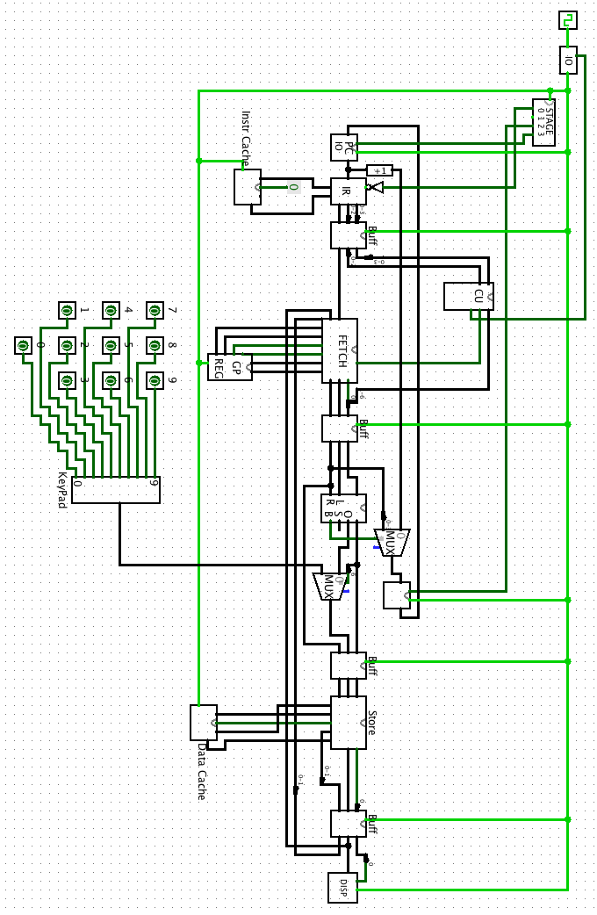
Functionality Overview:

- Clock
  - ticks are directed through IO (power unit)
  - if power is on
    - ticks are directed to each stage of CPU
- IO (power unit)
  - controlled by CU, controls clockticks
- Stage Counter
  - controls which stage is accepting ticks (3 outputs), increments every tick
- PC
  - incremented by stage Counter after the successful completion of an instruction
  - counts up to 16, then loops
- Instruction Cache
  - holds instructions (1 byte long), and addressed by the PC
  - Loads instructions to the Instruction Register (IR)
- Instruction Register
  - parses each instruction into 3 segments, adjusts to byte size, passes them to buffer
    - opcode (three bits)
    - functional opcode (three bits) used for arithmetic operations
    - arguments (5 bits)
- CU reads the opcode (and if ALU-op, sends the functional opcode to the ALU)
- fetch
  - inputs: byte address, byte 'value to write', 2 bit 'write flag', 1 bit 'addr flag', GP registers
  - outputs: 3 buffer bytes, 'x', 'y', and 'value'
- ALU
  - inputs: left byte (x from fetch stage), right byte(y from fetch stage), ALUop byte
  - outputs: branch bit, overflow bit, ALU-OUT byte
- Store
  - Purpose: this sub-circuit stores values. It can store values into the cache, general purpose register. Store can send values to the display and RAM.
  - Inputs: Operand byte (2bit register write flag, bit display flag, bit ram-write flag ), value byte, cache address byte, cache value byte
  - Outputs: 4 bit cache address, ram write flag, reg write flag, display flag, value to be stored
- Display
  - Purpose: The display takes as input a value, and a write flag. It's output is a digit from 0-9 on a simulated LED display.

Instructions Defined in Assembly
Each Instruction takes a byte. Notation [0-2] represents bits 0, 1, and 2. To input an instruction, begin writing from the least significant bit. Write from right to left (top to bottom).

Example Instruction: STORE(001) from register 0, into the byte addressed by 1100 in data cache.
Format: 11000001 == [1100][0][001] == [address in data cache] [register to read] [opcode]

Example Instruction: ALU-operation ADD R₀=R₀+R₁
Format: 001 10 111 == [001][10][111] == [ADD funct opcode] [reg 1] [

STOP:
Bit Format: [0-2][3-4][5-7]
[0-2] corresponds to the opcode, which is 011. [3-4] correspond to anything. [5-7] represents the function field. If anything in the function field is set to 1, it will be a HALT operation instead of a STOP operation.
Assembler Format: STOP
Assembler Format: HALT

STORE:
Bit Format: [0-2][3][4-7]
[0-2] corresponds to the opcode which is 001. [3] is the address of the register that is being read into memory, with 0= reg 0, 1=reg 1. [4-7] specifies the address which is being written in memory.
Assembler Format: STR Rx, Address

LOAD:
Bit Format: [0-2][3][4-7]
[0-2] corresponds to the opcode 010, and is basically the opposite of the STORE command. [3] is the address of the register being written to, and [4-7] is the address being read from.
Assembler Format: LD Ry, Address

PRINT:
Bit Format: [0-2][3]
[0-2] corresponds to the opcode 100. The third bit [3] specifies the register to be printed. This instruction only reads the first 4 bits of the register. Therefore it can only print from 0-9.
Assembler Format: PRT Rx

READ:
Bit Format: [0-2][3]
[0-2] corresponds to the opcode 011. The third bit [3] stores the keyboard input into the register at address specified by this bit.
Assembler Format: INP Rx

NOP
Bit Format: [0-2]
[0-2] this opcode is 000. An instruction with this opcode does nothing.
Assembler Format: NOP

BRANCH:
Bit Format: [0-2][3][4-7]
[0-2] corresponds to the opcode 101. When the register addressed by [3] is equal to zero, the CPU branches to instruction addressed by [4-7].
Assembler Format: BZ Rx Address

ALU:
Bit Format: [0-2][3][4][5-7]
[0-2] corresponds to the opcode 111. [3] specifies the first operand (A), [4] specifies the second operand (B), and [5-7] specifies the functional opcodes (below).

FUNCTIONAL OPCODES:
- 000: NOP
  - passes A through ALU without operation
  - Assembler Format: A-NOP Rx Ry
- 001: ADD
  - A=A+B¹
  - Assembler Format: A-ADD Rx Ry
- 010: SUB
  - A=A-B
  - Assembler Format: A-SUB Rx Ry
- 011: COMP
  - This functional opcode takes the two's complement of A
  - Assembler Format: A-COMP Rx Ry
- 100: MULT
  - A= A*B
  - Assembler Format: A-MULT Rx Ry
- 110: BZ
  - Checks A=0, then sets zero flag to true.
  - Assembler Format: A-BZ Rx Ry

PROGRAM:
Assembly:
LD r₀ 0000
INP r₁
BZ r₁ 0001
A-MULT r₀ r₁
PRT r₀

Machine Language:
0000 0 010
xxxx 1 011
0001 1 101
100 1 0 111
xxxx 0 100

- Section 1: Overview of CPU
  - 2.1. High level diagram of the entire CPU in one picture (one page)
  - 2.2. Overview of its functionality and flow (one page)
- Section 2: LOGISIM File Breakdown
3.1. Using a top-down approach, describe each part of the CPU (one or two pages)
- Section 3: The Assembly Language (two to four pages)
  - 4.1. Define your instructions in assembly
  - 4.2. Define your instruction bit formatting
  - 4.3. Describe how your instructions execute over the CPU
  - 4.4. Provide the requested program
- Section 4: Appendix (optional)
  - This place is for miscellaneous other things important for TA to have

(using operands defined above)
(using operands defined above)

